**Contents**

1.Title: 2

2.Abstract: 3

3.Objectives: 3

4.Results: 3

4.1. Simulation Environment: 3

4.2. Simulation Results: 9

4.3. Discussion: 11

5.Lab Task: 11

6.Conclusion: 12

7.References: 12

**MICROPROCESSOR & EMBEDDED SYSTEM LAB**

**Fall 21-22**

**Lab Report-9**

# 1.Title:

Familiarization with Raspberry Pi

|  |  |  |
| --- | --- | --- |
| **Group Member’s Name** | **ID** | **Department** |
| Ananya Chowdhury | 18-39028-3 | CSE |
| Durjoy Dey | 18-39013-3 | CSE |
| Nurul Huda Bhuiyan Rokon | 18-38983-3 | CSE |
| Tonima Hossain Pia | 18-38892-3 | CSE |
| Joy Karmakar | 18-39263-3 | CSE |
| Sazid Al Farabi | 19-39478-1 | CSE |
| Sharika Parvin Joba | 18-38721-3 | CSE |
| Salma Jahan Sahara | 18-38788-3 | CSE |

**Performance Date:** 25.11.21

**Submission Date:** 03.12.21

**Faculty Name:** DR. FERDOUS JAHAN SHAUN

**Section:** M

**Group:** B

**Submitted By:**

Sharika Parvin Joba, ID: 18-38721-3

Salma Jahan Sahara, ID: 18-38788-3

# 2.Abstract:

The main goal of this experiment is to demonstrate how to use raspberry pi and implementation of it in a LED control system using Proteus 8.9 Professional software. In this experiment we are going to implement virtual hardware in the creation of a LED control system. Here, we are going to implement LED, resistor, button (to turn on / off), control pins and virtual wire . In this experiment we will be using python code and implement it using the built-in IDE which will be used in the development of a simple LED control system which will function in a provided. Because of this, in this experiment we are going to use different hardware. In our class we used Proteus 8.9 Professional software for the simulation of raspberry pi. In the experiment we used simulated LED, resistor, button (to turn on / off), control pins and virtual wire provided in the simulation software As for control of the simulation we used the python code which we used to manipulated the system. Using the concepts, we learned about the raspberry pi and the implementation as well.

# 3.Objectives:

The main objectives are given below:

* Learn about the Raspberry Pi
* How we can use Raspberry Pi
* The implementation of blinking light (LED) using Raspberry Pi.

# 4.Results:

## 4.1. Simulation Environment:

Here we are using Proteus for this simulation.

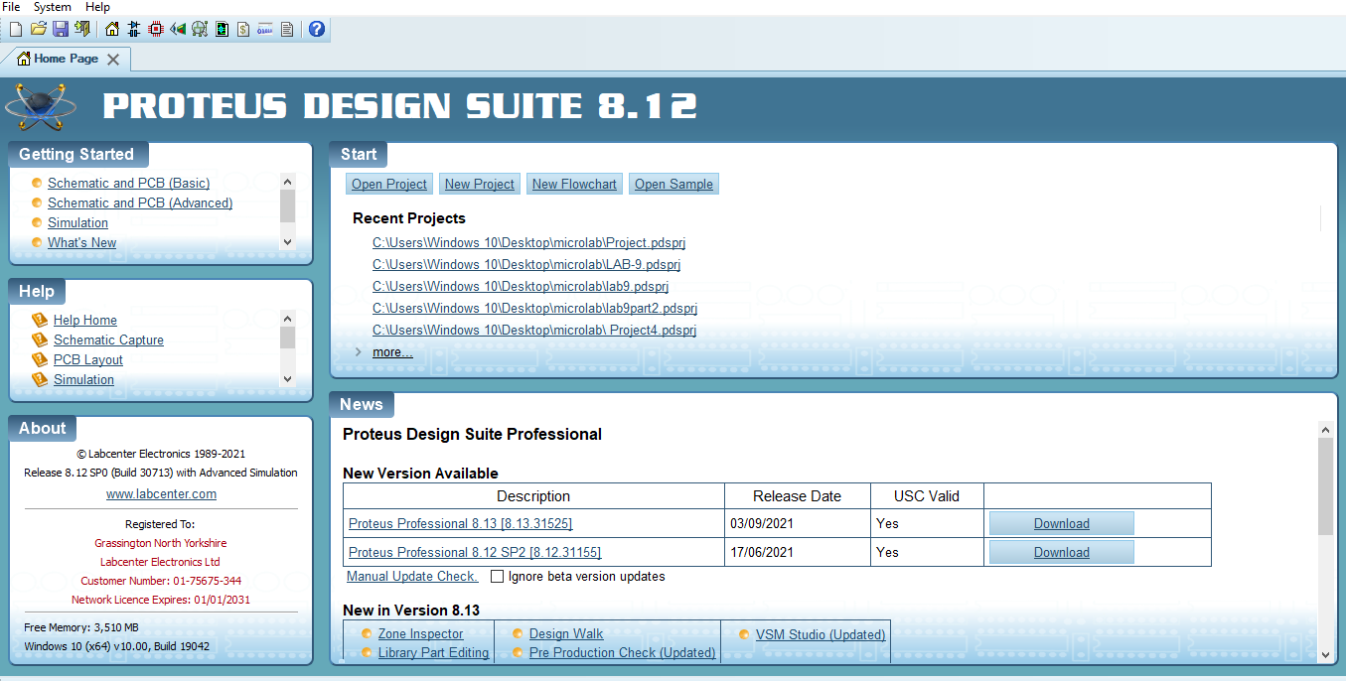

We have to click new project.

|  |
| --- |
|  |

Click on next.

|  |
| --- |
|  |

Next.

|  |
| --- |
|  |

Next.

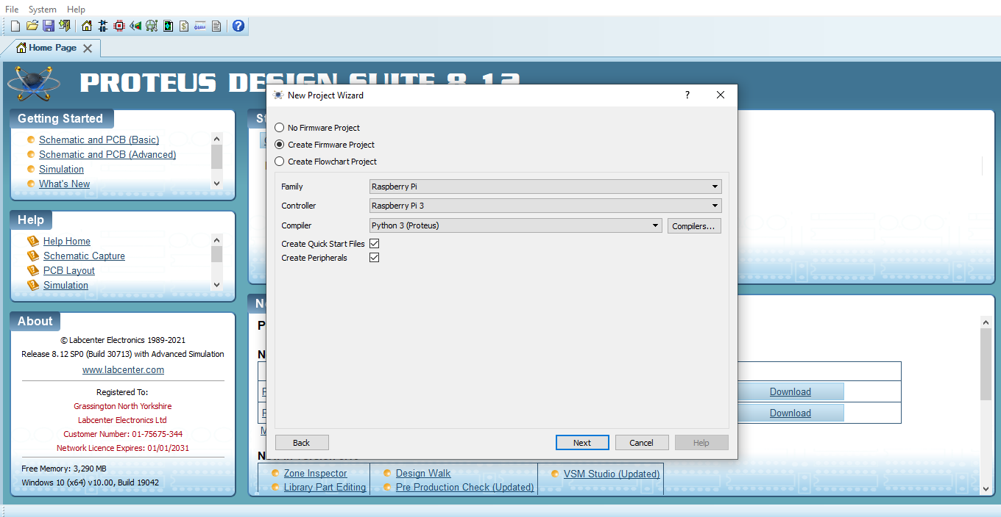

Select “Create Firmware Project ”

Then Next.

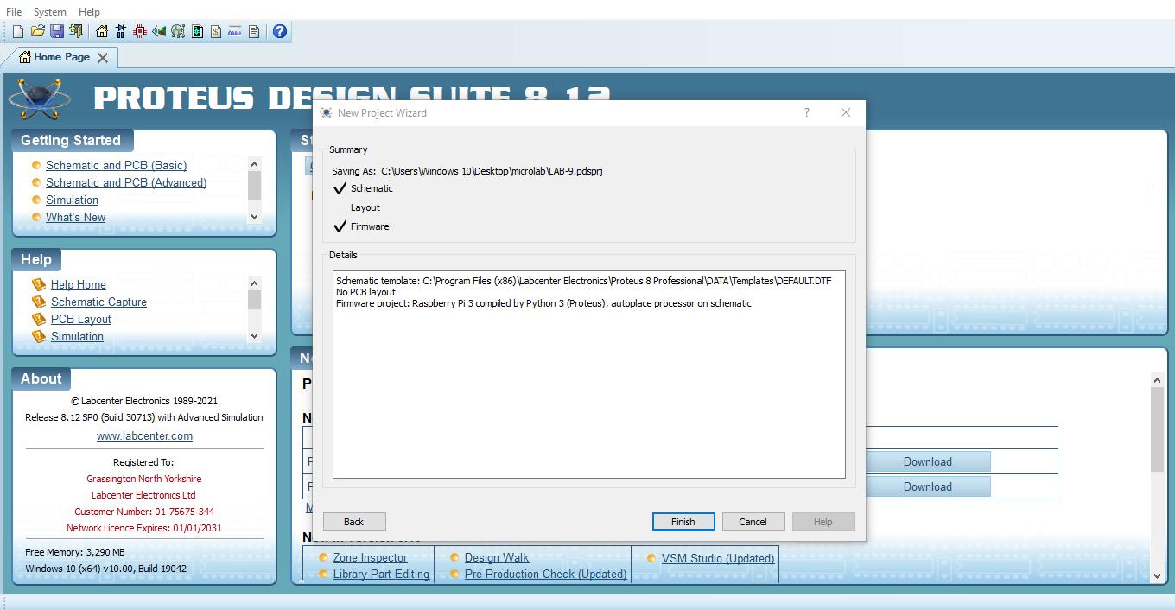

Next.

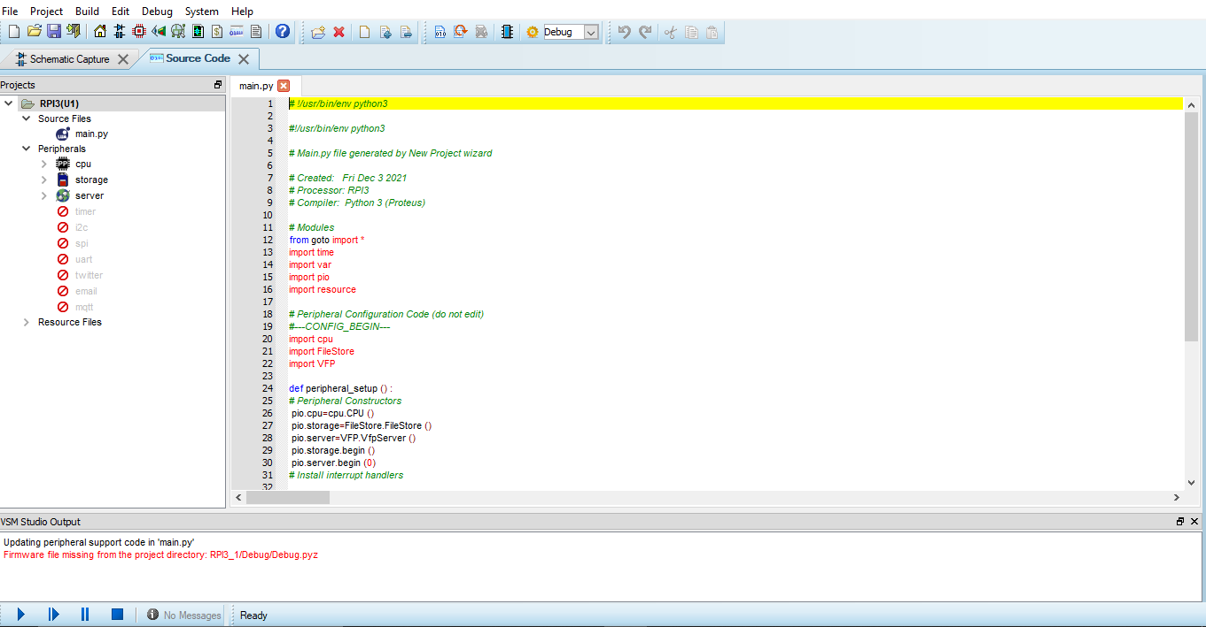

This is the page were we will write the python code.

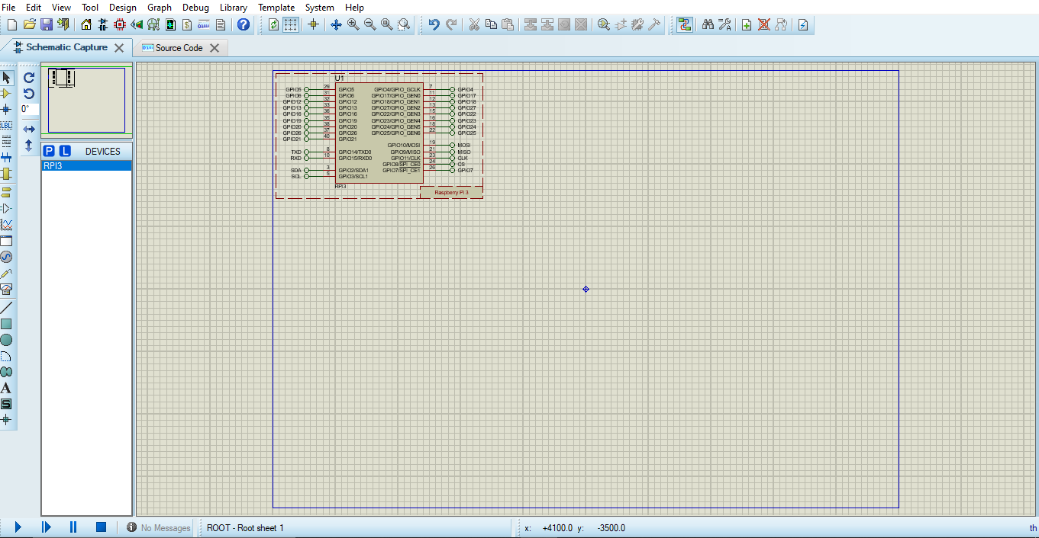

Here we will do the simulation

Then,

For doing the simulation with flowchart,

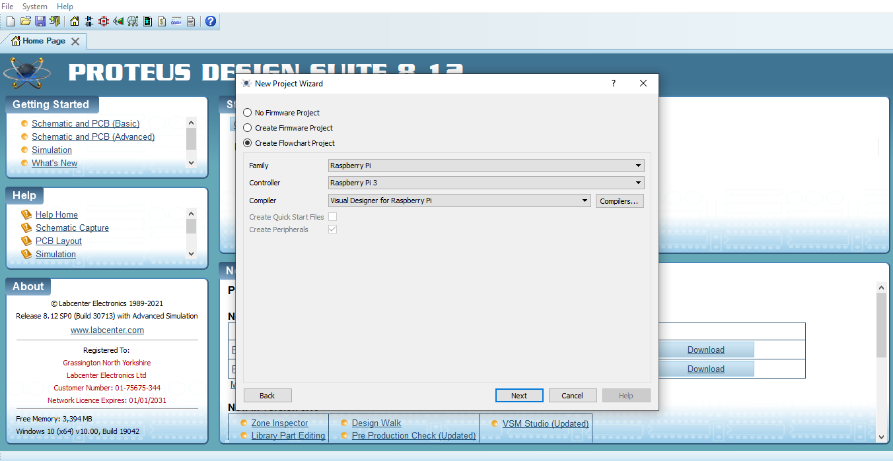

Select “Create FlowChart Project” then click on Next.

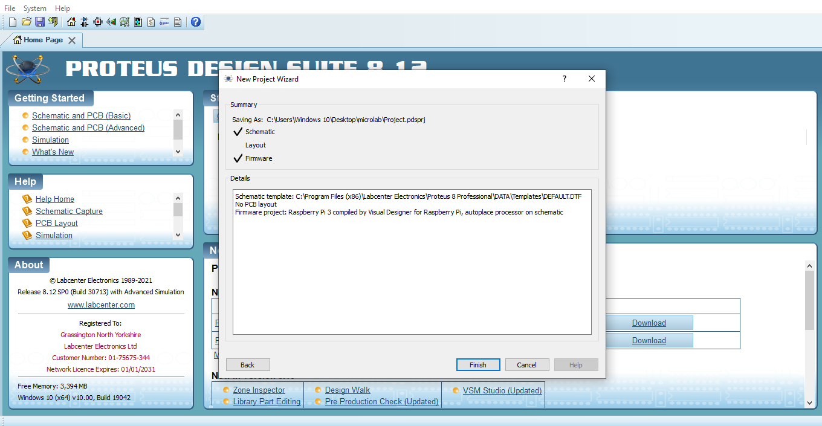

Next.

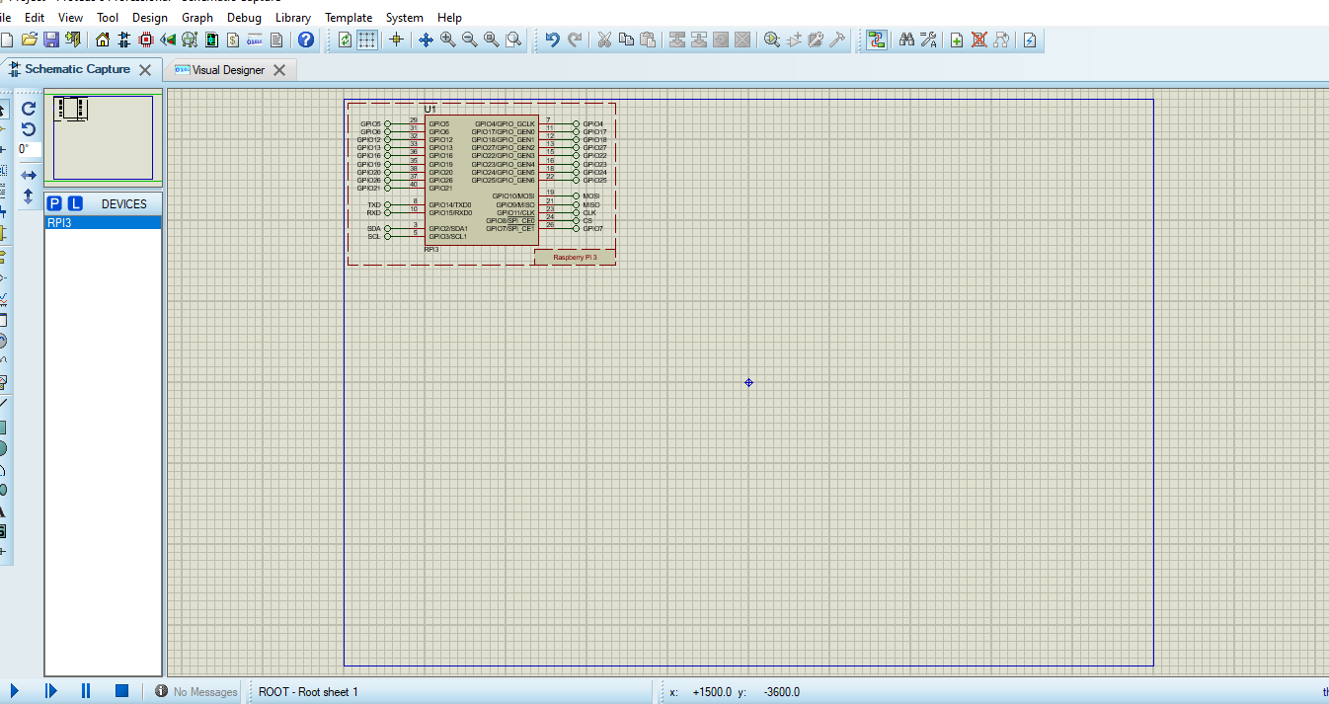

Here we will do the simulation.

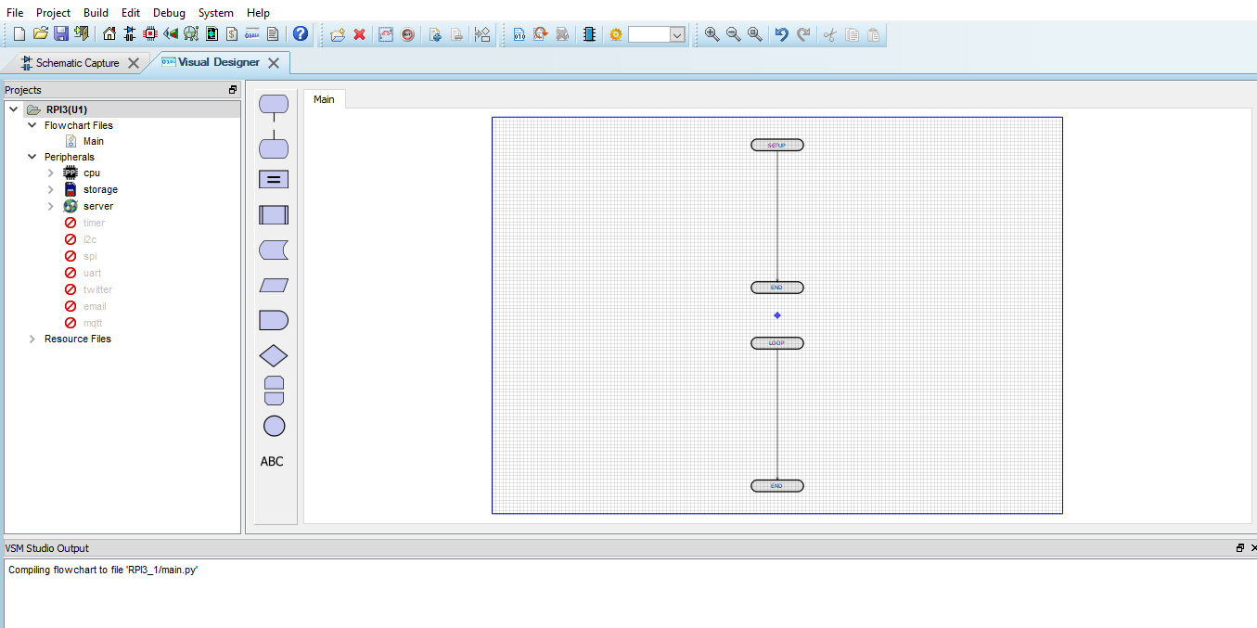

This page is for drawing the flowchart.

## 4.2. Simulation Results:

Here is the simulations,

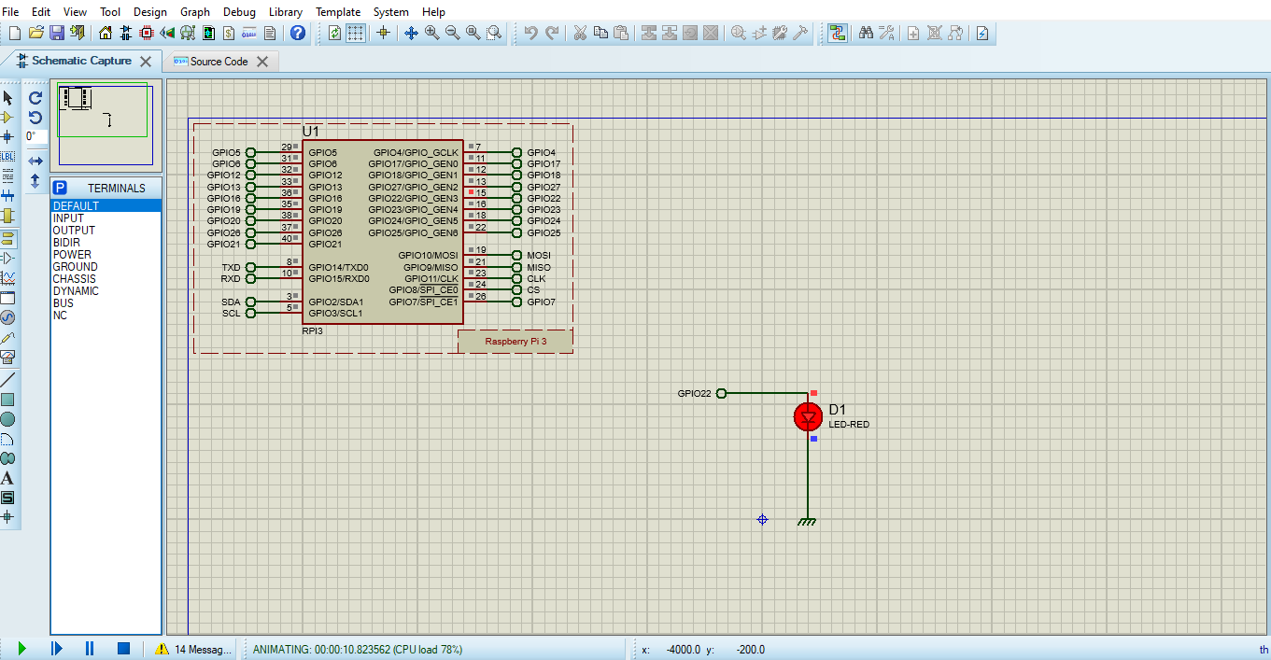

**Figure-1:** **LED turn on using Python code**

**Figure-3: LED Light turn on using Raspberry Pi**

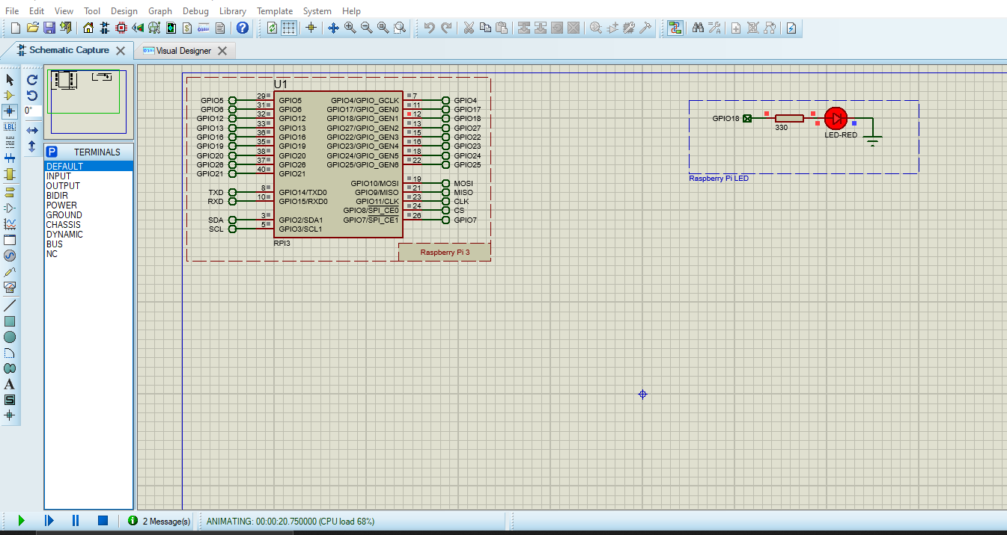

**Figure-2:.Python code for the simulation**

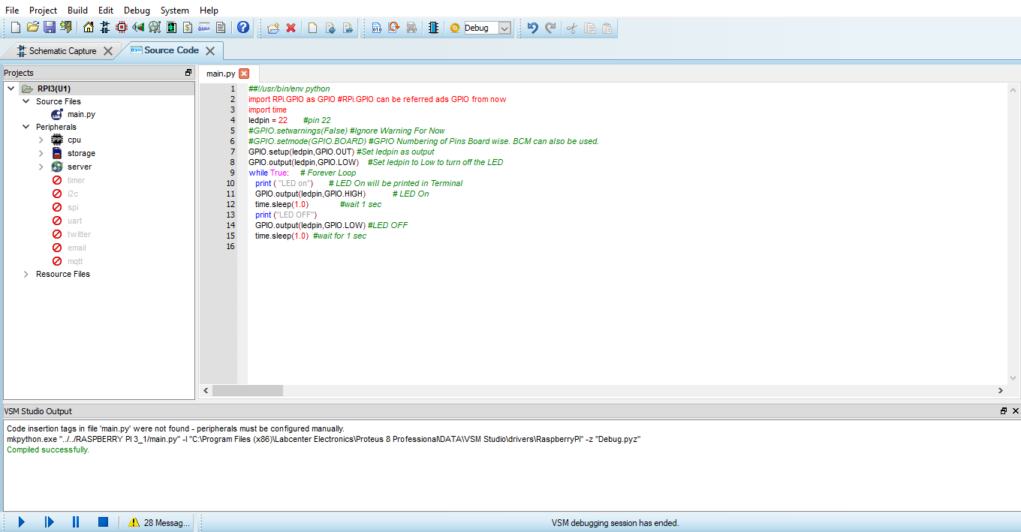

**Figure-4:Flow-Chart**

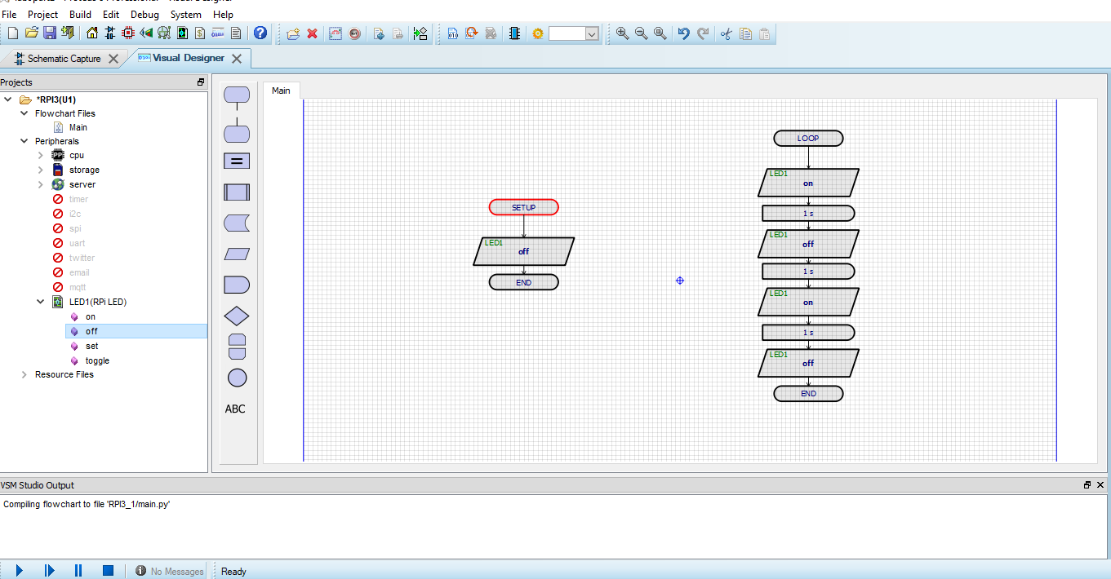

## 4.3. Discussion:

In the experiment we made Led Blink by using Raspberry Pi. For the First part same experiment, we used source code to blink the Led. The program design itself takes place on the Visual Designer tab and source code tab. It was quite easy because all the works in visual designer was done step by step which can be understood by anyone related to engineering field.

For this experiment second we do the flowchart on the Schematic. For implementing we used Proteus 8 professional. Then, we took Raspberry Pi and took Red Led. After that, with the condition in flowchart the Red led is blinked. Finally, the simulation was run and the result was observed successfully.

# 5.Lab Task:

* Design a traffic control system using RED, YELLOW and GREEN LEDs with 2 seconds interval of glowing state of each LED.
* This is the source code for this experiment:

##!/usr/bin/env python

import RPi.GPIO as GPIO #RPi.GPIO can be referred ads GPIO from now

import time

ledpin = 22 #pin 22

#GPIO.setwarnings(False) #Ignore Warning For Now

#GPIO.setmode(GPIO.BOARD) #GPIO Numbering of Pins Board wise. BCM can also be used.

GPIO.setup(ledpin,GPIO.OUT) #Set ledpin as output

GPIO.output(ledpin,GPIO.LOW) #Set ledpin to Low to turn off the LED

while True: # Forever Loop

print ( "LED on") # LED On will be printed in Terminal

GPIO.output(ledpin,GPIO.HIGH) # LED On

time.sleep(1.0) #wait 1 sec

print ("LED OFF")

GPIO.output(ledpin,GPIO.LOW) #LED OFF

time.sleep(1.0) #wait for 1 sec

# 6.Conclusion:

In this experiment, we can see in the outcome that our project works fine. The blinking of LED using Raspberry Pi and Python Program has been shown. This project will help to understand some basics of the GPIO Pins of Raspberry Pi.In this experiment, we were followed the instruction of our faculty and try to do it with the help of each group member. After facing a lot of difficulties. Finally, we achieved our destination.

# 7.References:

1) https://www.arduino.cc/.

2) https://www.labcenter.com/visualdesigner/